# MUTHAYAMMAL ENGINEERING COLLEGE

(Autonomous )

**Rasipuram -637408, Namkal (Dt)**

**DEPARTMENT OF MECHANICAL ENGINEERING**

**QUESTION BANK**

SUBJECT : **19GES28 & Engineering Mechanics**

YEAR / SEM : II / III

**UNIT I – BASICS AND STATICS OF PARTICLES**

**Part – A**

1. State the Second Law of Newton.
2. Write the equations of equilibrium of a coplanar system of forces
3. State Lami’s theorem with a neat sketch?
4. Differentiate between particles and rigid body?
5. State the Parallelogram law of forces?
6. State the triangular law of forces?
7. Could you explain the principle of transmissibility?
8. Distinguish the following system of forces with a suitable sketch. a) Coplanar b) Collinear.
9. Distinguish between Kinetics and Kinematics?
10. Solve the following: A force vector F= 700i + 1500j is applied to a bolt. Determine the magnitude of the force and angle it forms with the horizontal.
11. Compare ‘Resultant’ and ‘Equilibrant’
12. Describe unit vector?
13. Compare and contrast between particle and rigid body
14. State the Polygon Law of forces.
15. Find the resultant and direction of Force F̄ = 3i-4j.
16. Describe resultant of coplanar concurrent force system?
17. State the necessary and sufficient condition for static equilibrium of a particle in two dimensions?
18. Could you explain is a free body diagram?
19. Make clear the characteristics of the cross products
20. Describe equilibrium of a body and give conditions of equilibrium when subjected to forces.

**PART – B**

1. Five forces are acting on a particle as shown in figure 1 If the vertical component of all the forces is -1000 N, find the value of P. Also calculate the magnitude and direction of the resultant

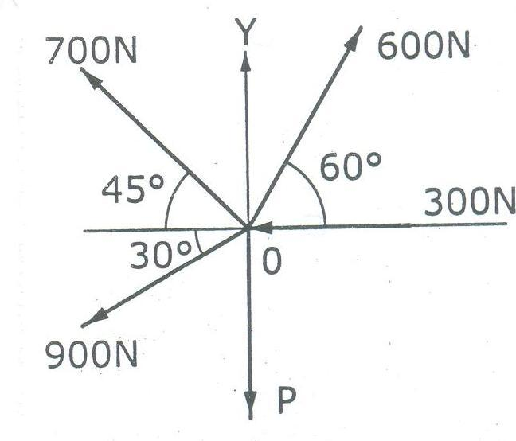

1. Find out the resultant of the system of forces given below:
2. 20N inclined at 30º towards north of east.
3. 25 N towards North.
4. 30N towards north west.

(iv) 35N inclined at 40º towards south of west.

1. Determine the resultant of system of forces acting as shown in Fig.

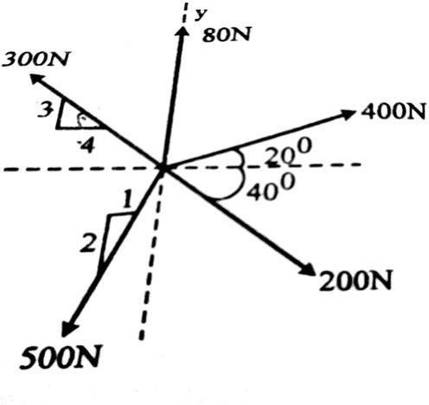

1. Determine the tension in cables BC & AC to hold 40 Kg load shown in fig.

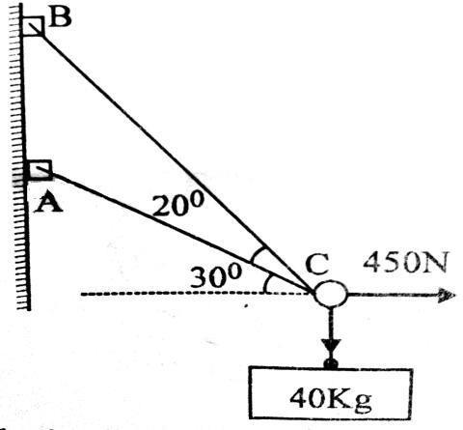

1. Two identical rollers each of weight 50N are supported by an inclined plane and a vertical wall as shown infig. Find the reactions at the points of supports A, B,and C.
2. Two cylinders E,F of diameter 60mm and 30mm. Weighing 160N and 40 N respectively are placed as shown in Fig. Assuming all the contact surfaces to be smooth, find the reactions at the contact points.

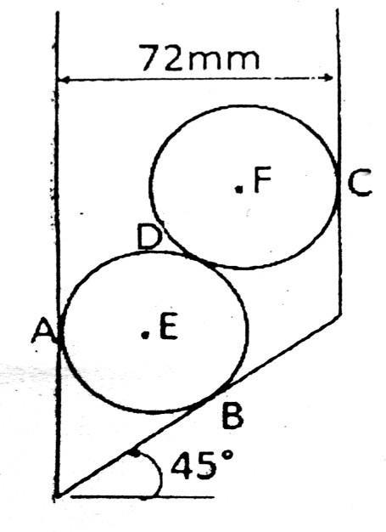

1. Two spherical shells rest between two vertical faces as shown in figure 3. The radius of the smaller shell is 10cm and its weight is 36N, the radius of the larger is 15cm and its weight is 120N. The distance between the two faces is 45cm. Find the reactions at A,B,C and D.

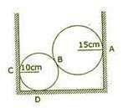

1. A string ABCD attached to two fixed points A and D has two equal weights of 1000N attached to it B and C. the weights rest with the portion AB and CD inclined at angles of 30˚ and 60˚ respectively, to the vertical as shown in figure 1. Find the tensions in the portion AB, BC, and CD of the string, if the inclination of the portion BC with the vertical is 120˚.

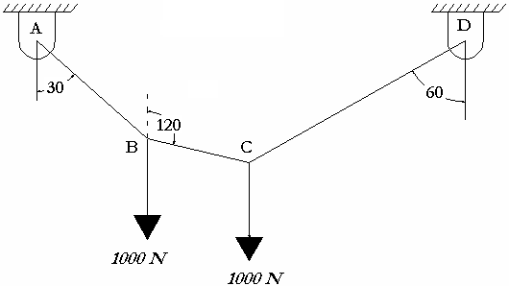

1. Determine the magnitude and direction of force F shown in figure so that particle ‘O’ is in equilibrium

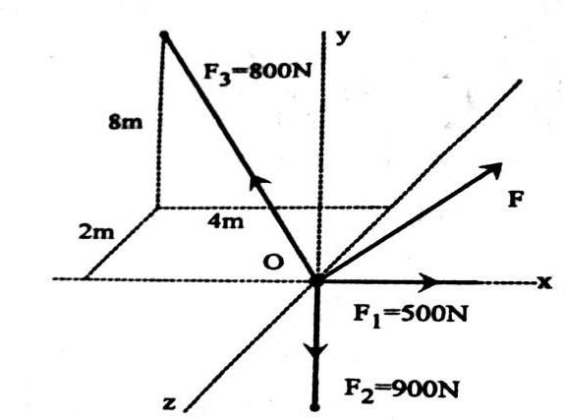

1. Forces 32 KN, 24 KN, 24 KN and 120 KN are concurrent at origin (0,0,0) and are respectively directed through the points whose coordinates are A (2,1,6) B(4,-2,5) C(-3,-2,1) and D (5,1,-2). Determine resultant of the system.

**UNIT II - EQUILIBRIUM OF RIGID BODIES**

**PART – A**

1. Could you explain the force couple system?
2. Determine the resultant of the force systems shown in figure

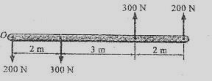

1. State Varignon’s theorem.
2. When is moment of force zero about a point?
3. Describe the couple.
4. Why the couple moment is said to be a free vector?
5. Distinguish between couple and moment?
6. When is moment of force maximum about a point?
7. State the different types of supports.
8. Write down the conditions of equilibrium of a particle in space.
9. What are the reactions at a fixed support of a plane beam that are possible?
10. List the different types of beams?
11. Statethe necessary and sufficient conditions for equilibrium of rigid bodies in two dimensions?
12. What are the reactions at a fixed support of a plane beam that are possible?
13. Predict how you will reduce a force into an equivalent force- couple system.
14. A line of action of a 50 N force is passing through the points A [1,8,7]m and B [7,1.6,2.2]m. The coordinates being given in m. What is the moment of the force about a point C[4,6,3] ?
15. Discuss about the equation of equilibrium of a rigid body.
16. Find the moment of 20 N force about the point 'O' as shown in Fig.

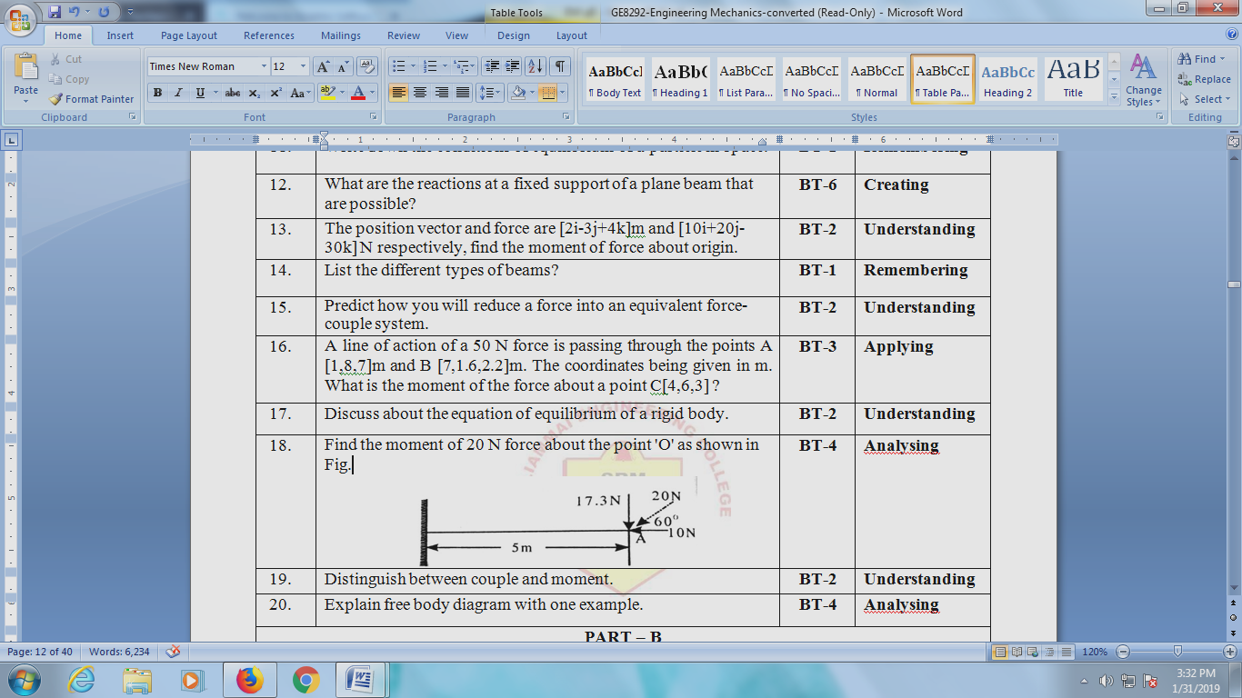

1. Write the equation of equilibrium of a rigid body?
2. Explain free body diagram with one example.

**Part – B (16 Marks)**

1. Find the support reactions of a beam shown in figure.

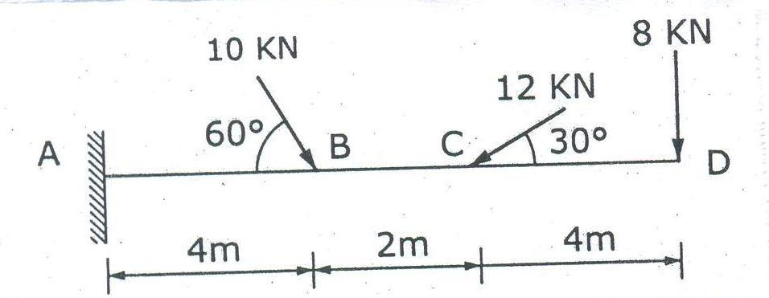

1. Reduce the given system of forces acting on the beam AB in fig. to
2. an equivalent force couple system at A (ii)an equivalent force couple system at B

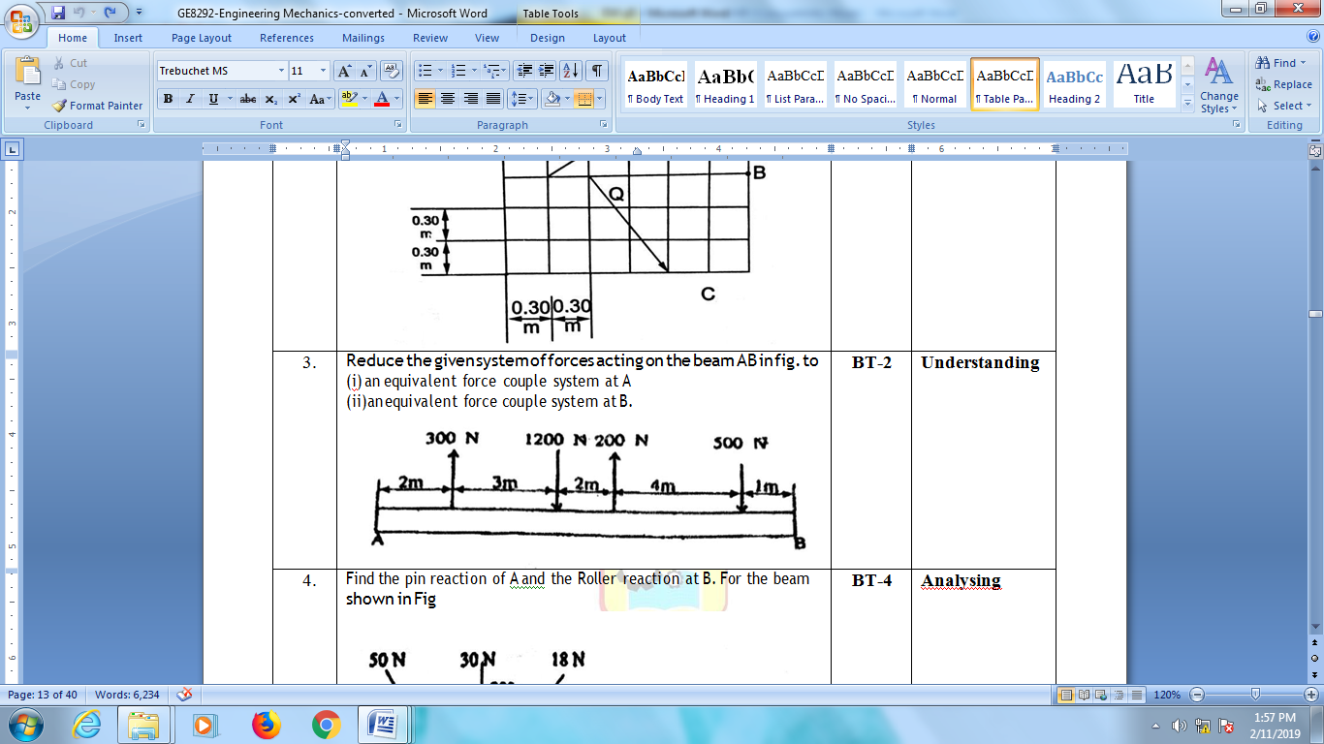

1. Find the pin reaction of A and the Roller reaction at B. For the beam shown in Fig

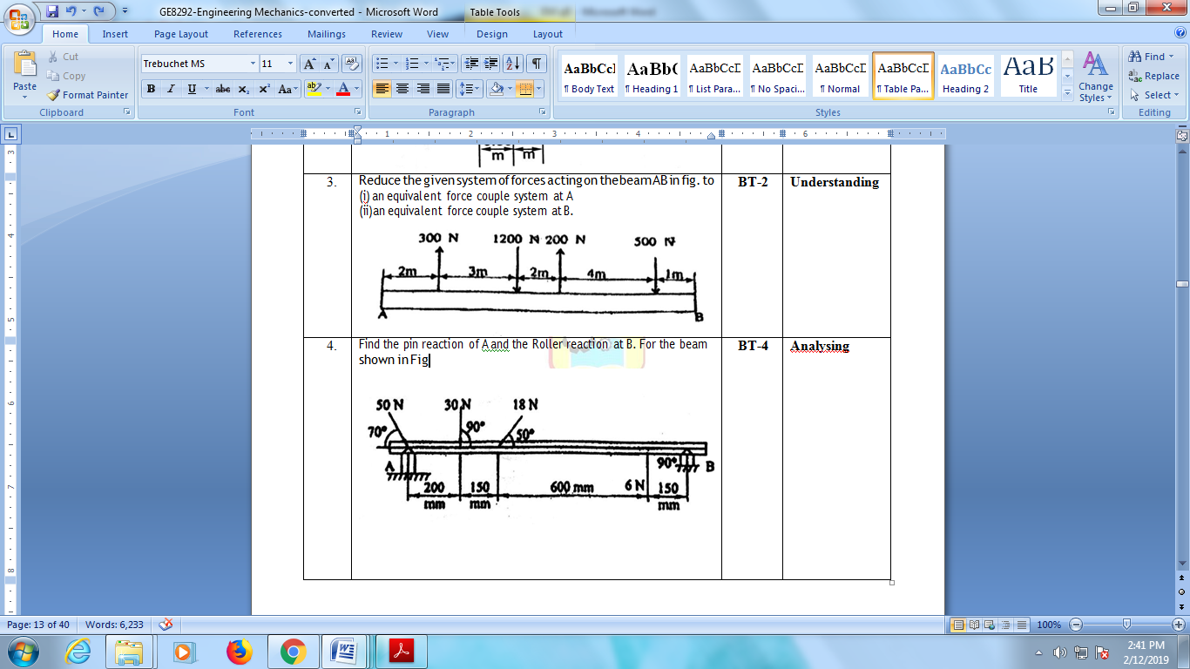

1. Illustrate the system of forces shown in fig to a force – couple system at A

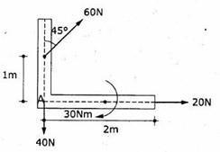

1. Determine the tension in cable BC as shown in figure. Neglect the self-weight of AB.

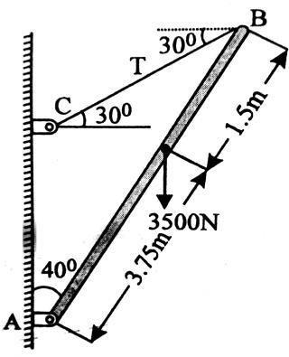

1. Blocks A and B of weight 200N and 100N respectively, rest on a 30 inclined plane and are attached to the post which is held perpendicular to the plane by force P, parallel to the plane, as shown in fig. Assume that all surfaces are smooth and that the cords are parallel to the plane. Determine the value of P. Also find theNormal reaction of Blocks A and B.

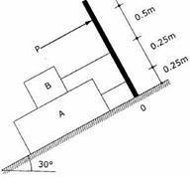

1. A uniform meter rod AB, assumed rigid of mass 0.5 Kg is suspended from its end in an inclined position and a mass of 1 Kg is suspended from a point D, as shown in Fig, Determine the tension in each string. Where should the suspended mass be placed in order to get equal tension in the strings.

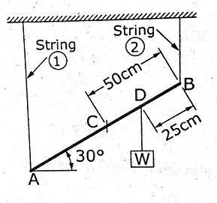

1. Determine the support reactions of a simply supported beam, subjected to the loads as shown figure.

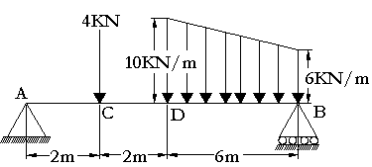

1. Find the reactions at points A & B.

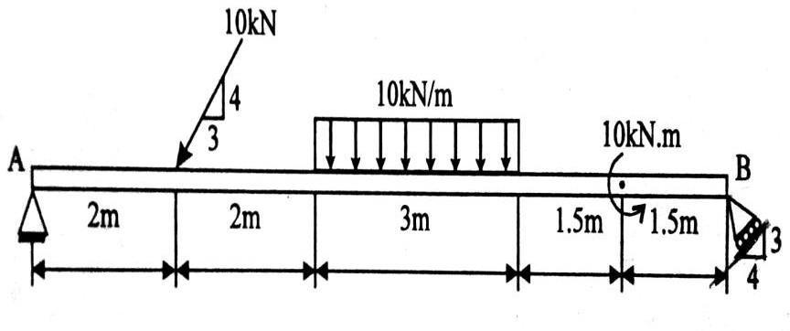

1. Calculate the reactions R1, R2 and R3 for the two beams AB and CD supported as shown in Fig,. There being a Hinge connecting B and C

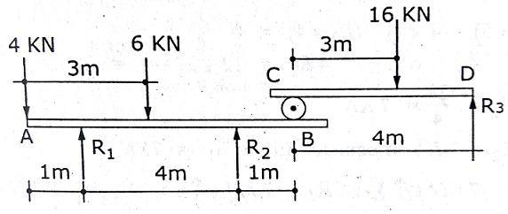

**UNIT III - PROPERTIES OF SURFACES AND SOLIDS**

**Part – A (2 Marks)**

1. Define centroid and centre of gravity of a area
2. State parallel axis theorem and perpendicular axis therorem.
3. Define principal axes and principal moment of inertia
4. Define product of inertia.
5. Define polar moment of inertia.
6. Differentiate Centroid and centre of gravity
7. Discuss about the expression for finding mass moment of inertia of a cylinder of radius ‘R’ and height ‘h’ about its base.
8. State the Pappas guildinus area theorem
9. State the Pappas guildinus volume theorem
10. Discuss about the Polar moment of Inertia and state its significant.
11. Compare and contrast the Area moment of Inertia with mass moment of inertia.
12. Define Radius of gyration.
13. State the relationship between the second moment of area and mass moment of inertia of a uniform plate.
14. Compare and contrast moment and second moment about an axis.
15. What is the radius of gyration of a circle of diameter ‘d’ about its diameter.
16. Describe the various methods of finding the centre of gravity of a body
17. Explain the difference between the centre of gravity and centre of mass.
18. State and prove first theorem of Pappus.
19. State parallel axis theorem with a line diagram.
20. What is the built-up section?

**Part – B (16 Marks)**

1. Locate the principal axes and determine the maximum and minimum moments of inertia of the angle section shown in figure 4**,** with respect to its centroidal axis

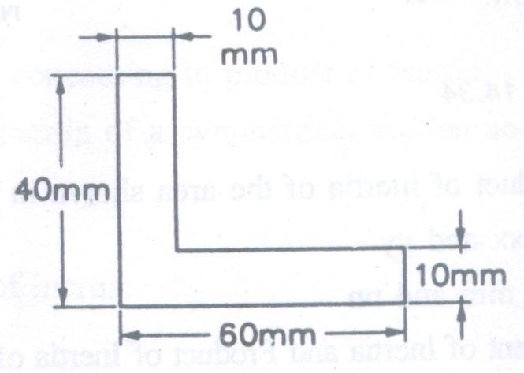

1. Find the centroid of the plane lamina shown in _Figure

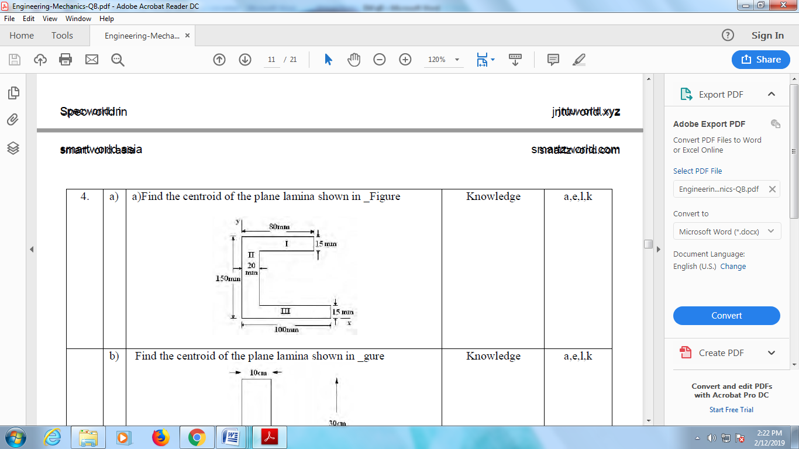

1. Design Moment of Inertia about the co-ordinate axes of plane area shown in fig. Also find Polar Moment of Inertia. All the dimensions are in 'mm'

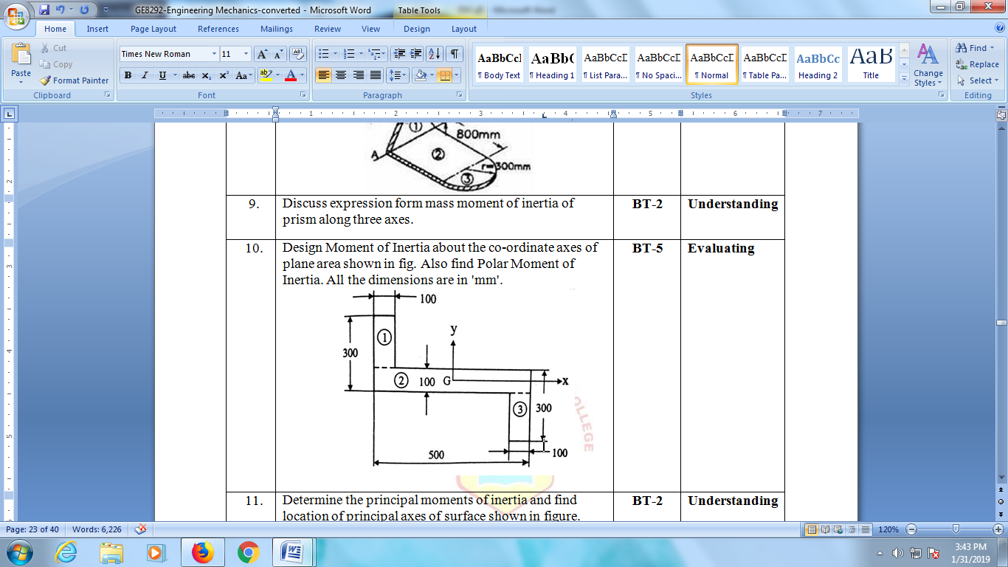

1. Illustrate the polar moment of inertia and polar radius of gyration of plane area about centroidal axes shown in fig

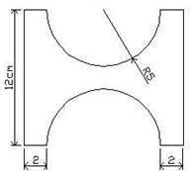

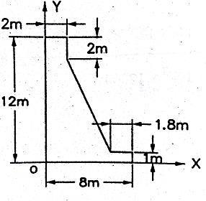

1. Find the centroid of the plane lamina shown in figure

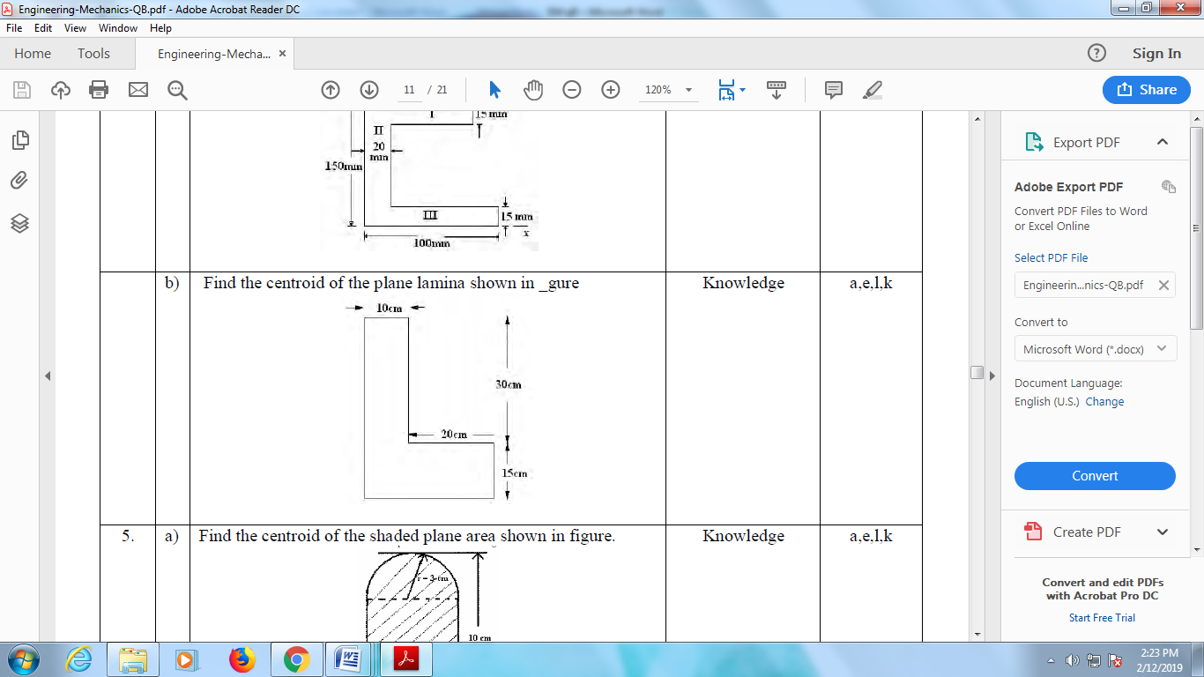

1. Determine the moment of inertia of the inverted T-section shown in figure about an axis passing through the centroid of the section and perpendicular to the stem

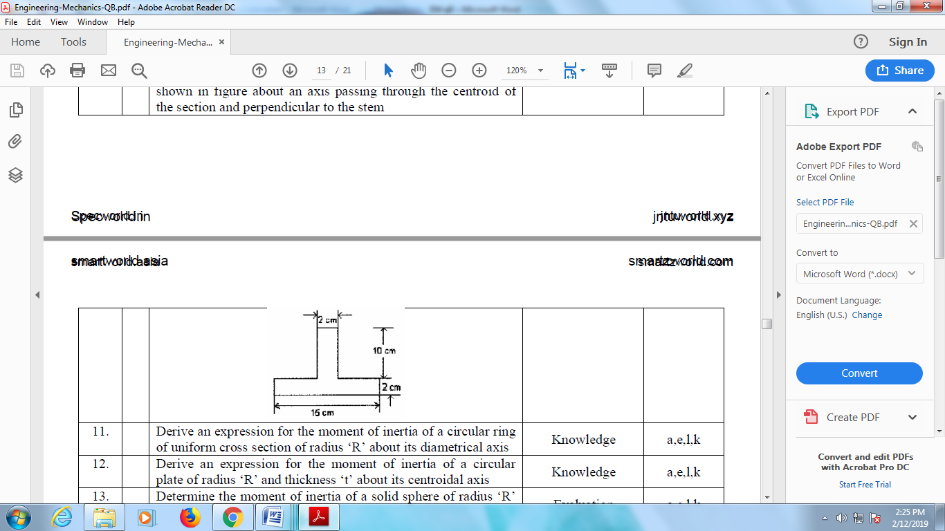

1. Determine the moment of inertia of the shaded area as shown in figure with respect to the x axis

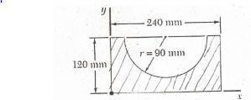

1. Determine the coordinates of centroid of the shaded area as shown in figure, if the area removed is semicircular. All dimensions are in mm

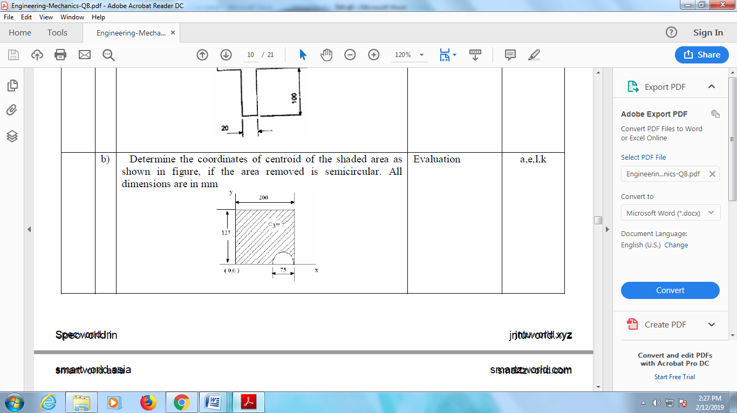

1. Determine the co-odinates of centroid of the shaded area shown in figure.

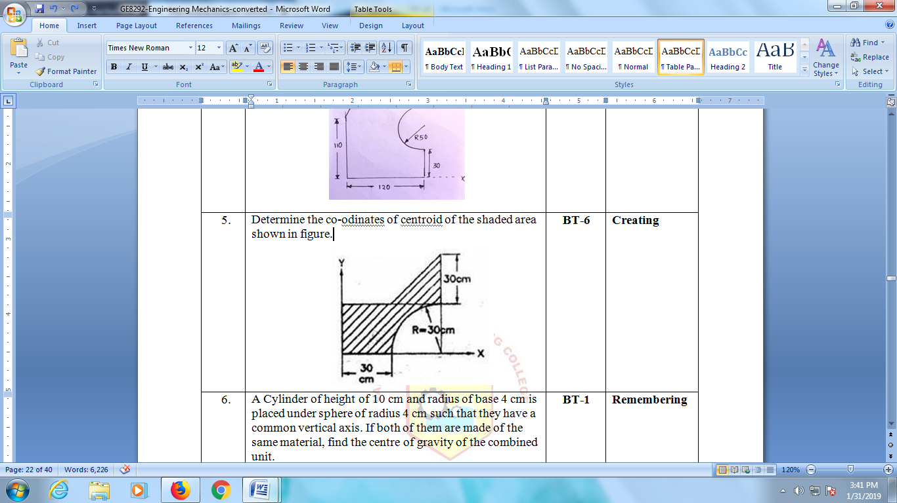

1. For the section shown in Fig,. Below, determine the moment of inertia values about (1) – (1) and (2) – (2) axes.

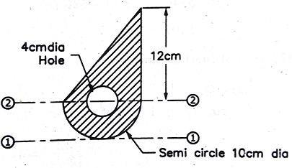

**UNIT IV - DYNAMICS OF PARCTICLES**

**Part- A (2 Marks)**

1. Differentiate linear and angular momentum.
2. State D’Alembert’s principle
3. Discuss about the equations of motion of a particle under gravitation.
4. A car accelerates uniformly from a speed of 30 kmph in 5 seconds. Determine the acceleration of the car and the distance travelled by the car during 5 seconds.
5. Give the dynamic equilibrium conditions.
6. Give short notes on law of conservation of momentum.
7. Solve the following: A stone is projected in space at an angle of 45° to horizontal at an initial velocity of 10 m/sec. Find the range of the projectile.
8. Could you elucidate the work energy principle?
9. Illustrate the impulse momentum equation?
10. Distinguish between kinetics and kinematics.
11. what are motion curves.
12. Define the term co-efficient of restitution.
13. Distinguish between impulse and impulsive force.
14. Analyze the impulse momentum equation.
15. Compare and contrast the rectilinear and curvilinear motion.
16. Define inertia force.
17. What differences exist between impulse and momentum
18. Compare and contrast the impact and elastic impact
19. Define Co-efficient of restitution
20. State Newton’s law of collision of elastic bodies.

**Part – B (16 Marks)**

1. A body A is projected vertically upwards from the top of a tower with a velocity of 40 m/s, the tower being 180m high. After t sec, another body B is allowed to fall from the same point. Both the bodies reach the ground simultaneously. Calculate t and the velocities of A and B on reaching the groun
2. Two bodies of 9 kg and 13.5 kg are suspended on two ends of a string passing over a pulley of radius 275 mm and mass moment of inertia = 16.5kg m2 as shown. Determine the tensions in the strings and the angular acceleration of the pulley

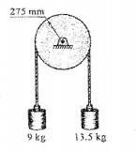

1. The position of the particle is given by the relation S=1.5t3-9t2-22.5t+60, where S is expressed in meters and t in seconds. Determine (i) the time at which the velocity will be zero (ii) the position and distance travelled by the particle at that time (iii) the acceleration of the particle at that time and (iv) the distance travelled by the particle from t = 5s to t = 7s.
2. Two weights 80 N and 20 N are connected by a thread and move along a rought horizontal plane under the action of a force 40 N, applied to the first weight of 80 N as shown in figure. The coefficient of friction between the sliding surfaces of the wrights and the plane is 0.3. Design the acceleration of the weights and the tension in the thread using work-energy equation.

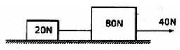

1. Two Blocks A and B of weight 100 N and 200 N respectively are initially at rest on a 30° inclined plane asshown in figure. The distance between the blocks is 6 m. The co efficient of friction between the block A and the plane is 0.25 and that between the block B and the plane is 0.15. If they are released at the same time, in what time the upper block (B) reaches the Block (A).

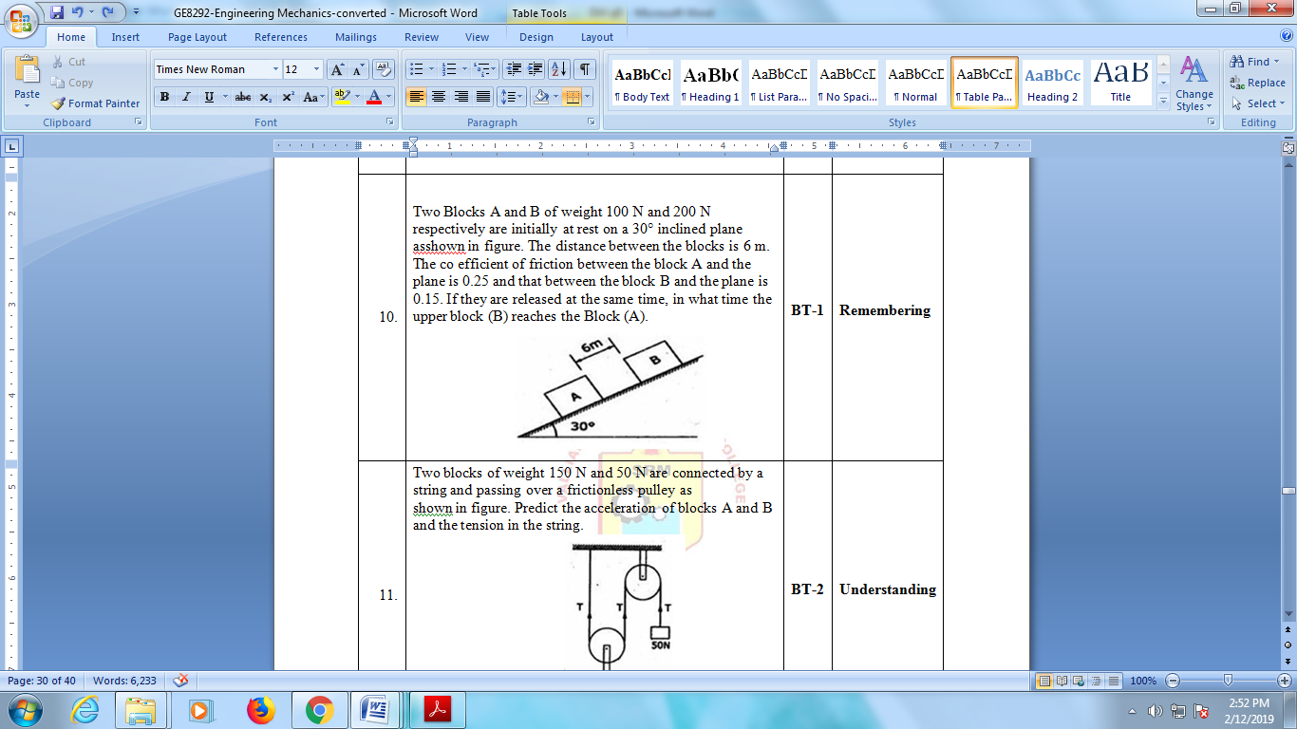

1. The equation of motion of a particle is given, acceleration interms of time (t) as below. A = 3t2 + 2t+4, in which acceleration is in m/s2 and time t is in seconds. It is observed that the velocity of the particle is 2 m/s after 4 seconds; and the displacement of the particle is 8 m after 8 seconds. Determine Velocity after 8 seconds and Displacement after 2 seconds.
2. Two blocks of weight 150 N and 50 N are connected by a string and passing over a frictionless pulley as shown in figure. Predict the acceleration of blocks A and B and the tension in the string.

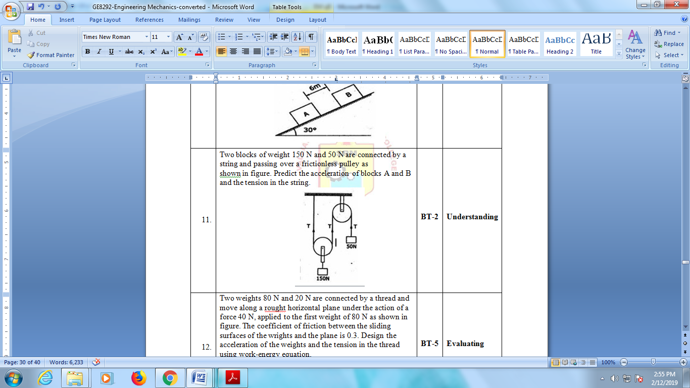

1. A stone is thrown vertically upwards with a velocity of 19.6m/s from the top of a tower 24.5m height. Calculate the a) time required for the stone to reach the ground. b) velocity of the stone in its downward travel at the point in the same level as the point of projection. c) The maximum height to which the stone will rise in its flight
2. A projectile is aimed at a target on the horizontal plane and falls 12 m short when the angle of projection is 150, while it overshoots by 24m when the angle is 450. Find the, angle of projection to hit the target.
3. A train is traveling from A to D along the track shown in fig. Its initial velocity at A is zero. The train takes 5 min to cover the distance AB, 2250 m length and 2.5 minutes to cover, the distance BC, 3000 m in length, on reaching the station C, the brakes are applied and the train stops 2250 m beyond, at D (i) Find the retardation on CD, (ii) the time it takes the train to get from A to D, and (iii) its average speed for the whole distance.

**UNIT V – FRICTION**

**Part – A (2 Marks)**

1. Describe angle of friction.
2. Define limiting friction.
3. Show that the mathematical definitions of velocity and acceleration.
4. Compare and contrast Ladder friction and Wedge friction.
5. Describe friction and classify its types.
6. Classify the types of friction.
7. Discuss about the coefficient of static friction.
8. Discuss about the coulomb’s laws of dry friction.
9. Define rolling resistance.
10. Discuss coefficient of rolling resistance?
11. Analyze the coefficient of friction and express its relationship with angle of friction.
12. Illustrate the characteristics of general plane motion
13. Enumerate general plane motions with some examples.
14. Compare Co-efficient of friction and angle of friction
15. Describe coulomb’s laws of dry friction.
16. Define impending motion.
17. State angle of repose.
18. Could you explain Angular momentum?
19. How will you calculate the linear restoring force of an elastic material.
20. Define instantaneous centre of rotation.

**Part – B (16 Marks)**

1. Two blocks 'A' and 'B' of masses mA = 280 kg and mB = 420 kg are jointed by an inextensible cable as shown in Fig. Assume that the pulley is frictionless and µ = 0.30 between block 'A' and the surface. The system is initially at rest. Determine (i) Acceleration of block A (ii) velocity after it has moved 3.5 m and (iii) velocity after 1.5 seconds

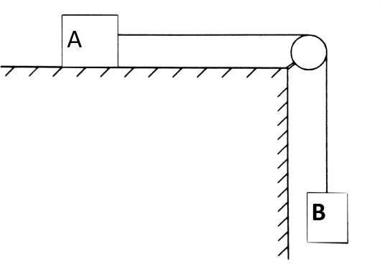

1. A 10,000 kN train is accelerated at a constant rate up a 2% grade. The track resistance is constant at 9N/kN. The velocity increases from 9m/sec to 18m/sec in a distance of 600 metres. Determine the maximum power developed by the locomotive.
2. Determine the magnitude and the direction of the resultant of two forces 7 N and 8 N acting at a point with an included angle of 60o with between them. The force of 7 N being horizontal
3. An effort of 200 N is required just to move a certain body up an inclined plane of angle 15°, the force is acting parallel to the plane. If the angle of inclination of the plane is made 20°, the effort required being again parallel to the plane, is found to be 230 N. Predict the weight of the body and coefficient of friction.
4. Two blocks A and B of mass 50 kg and 100 kg respectively are connected by a string C which passes through a frictionless pulley connected with the fixed wall by another string D as shown in figure. Find the force P required to pull the lock B. Also find the tension in the string D. Take coefficient of friction at all contact surfaces as 0.3.

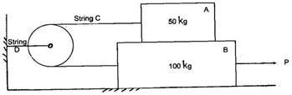

1. Two weights each of 100N are suspend from a compound pulley as shown in Fig. Find
2. Angular acceleration of the pulley
3. Linear acceleration of the blocks A&B
4. Tension in the string.

Take weight of the pulley as 300 N and its radius of gyration 0.25m.

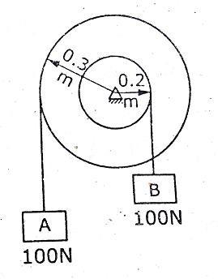

1. Two blocks A and B of weights 300N and 400N respectively are connected by a string as shown in Fig,

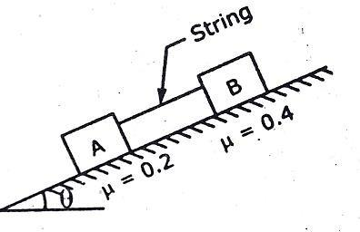

The coefficient of static friction under the block A is 0.2 and under the block B is 0.4. Determine the angle at which the bodies will slide down the plane.

1. A mass of 20kg is projected up an inclined of 260 with velocity of 4m/s. If μ=0.2

i.Find maximum distance that the package will move alongthe plane and ii.What will be the velocity of the package when it comesback to initial position?

1. Two particles of masses 10kg and 20kg are moving along a straight line towards each other at velocities of 4m/s and 1m/s respectively. Determine the velocities of the particles immediately after their collision. Also find the loss of kinetic energy.
2. Find the power required to pull a train up an incline of 1 in 200 at a speed of 36 kmph, if the weight of the train is 3000 kN and the track resistance is 5 N/kN. Also determine the maximum speed with which the train moves up on incline of 1 in 100 with the same power.